Pupil made Mystery B

 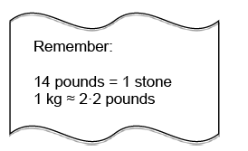

Nerys sees a very big fish. She is told it weighs 15kg.

Nerys herself weighs 9 stone 4 pounds. Complete the following sentence.

Nerys weighs approximately ……………………… times as much as the fish.

[6 marks]

Write a mystery from this question. You can put in some red herrings and you don’t need to use all of the boxes. You can include hint cards too.

|  |  |  |
| --- | --- | --- |
|  |  |  |
|  |  |  |
|  |  |  |
|  |  |  |
|  |  |  |