Creating a mathematics learning community through ensemble
In order for mixed attainment teaching to be successful, it is essential that the learners see themselves as part of a co-operative and mutually supportive learning community rather than as isolated individuals in competition with one another. Complicite's curriculum project Embodying Mathematics to which I contributed occurred in primary schools in London and Sheffield. But the ideas around using embodiment and ensemble to build such a learning community and the mathematical connections made within the project extend, at least, to mathematics classrooms in the early years of secondary school.
The ensemble is a group of people who work together, all of whom are equally important to achieving whatever it is they are working on. Everyone is involved and everyone succeeds. It draws on the basic ideas of the power of the circle, of taking time and of working together. Everyone is valued, everyone is equally important.
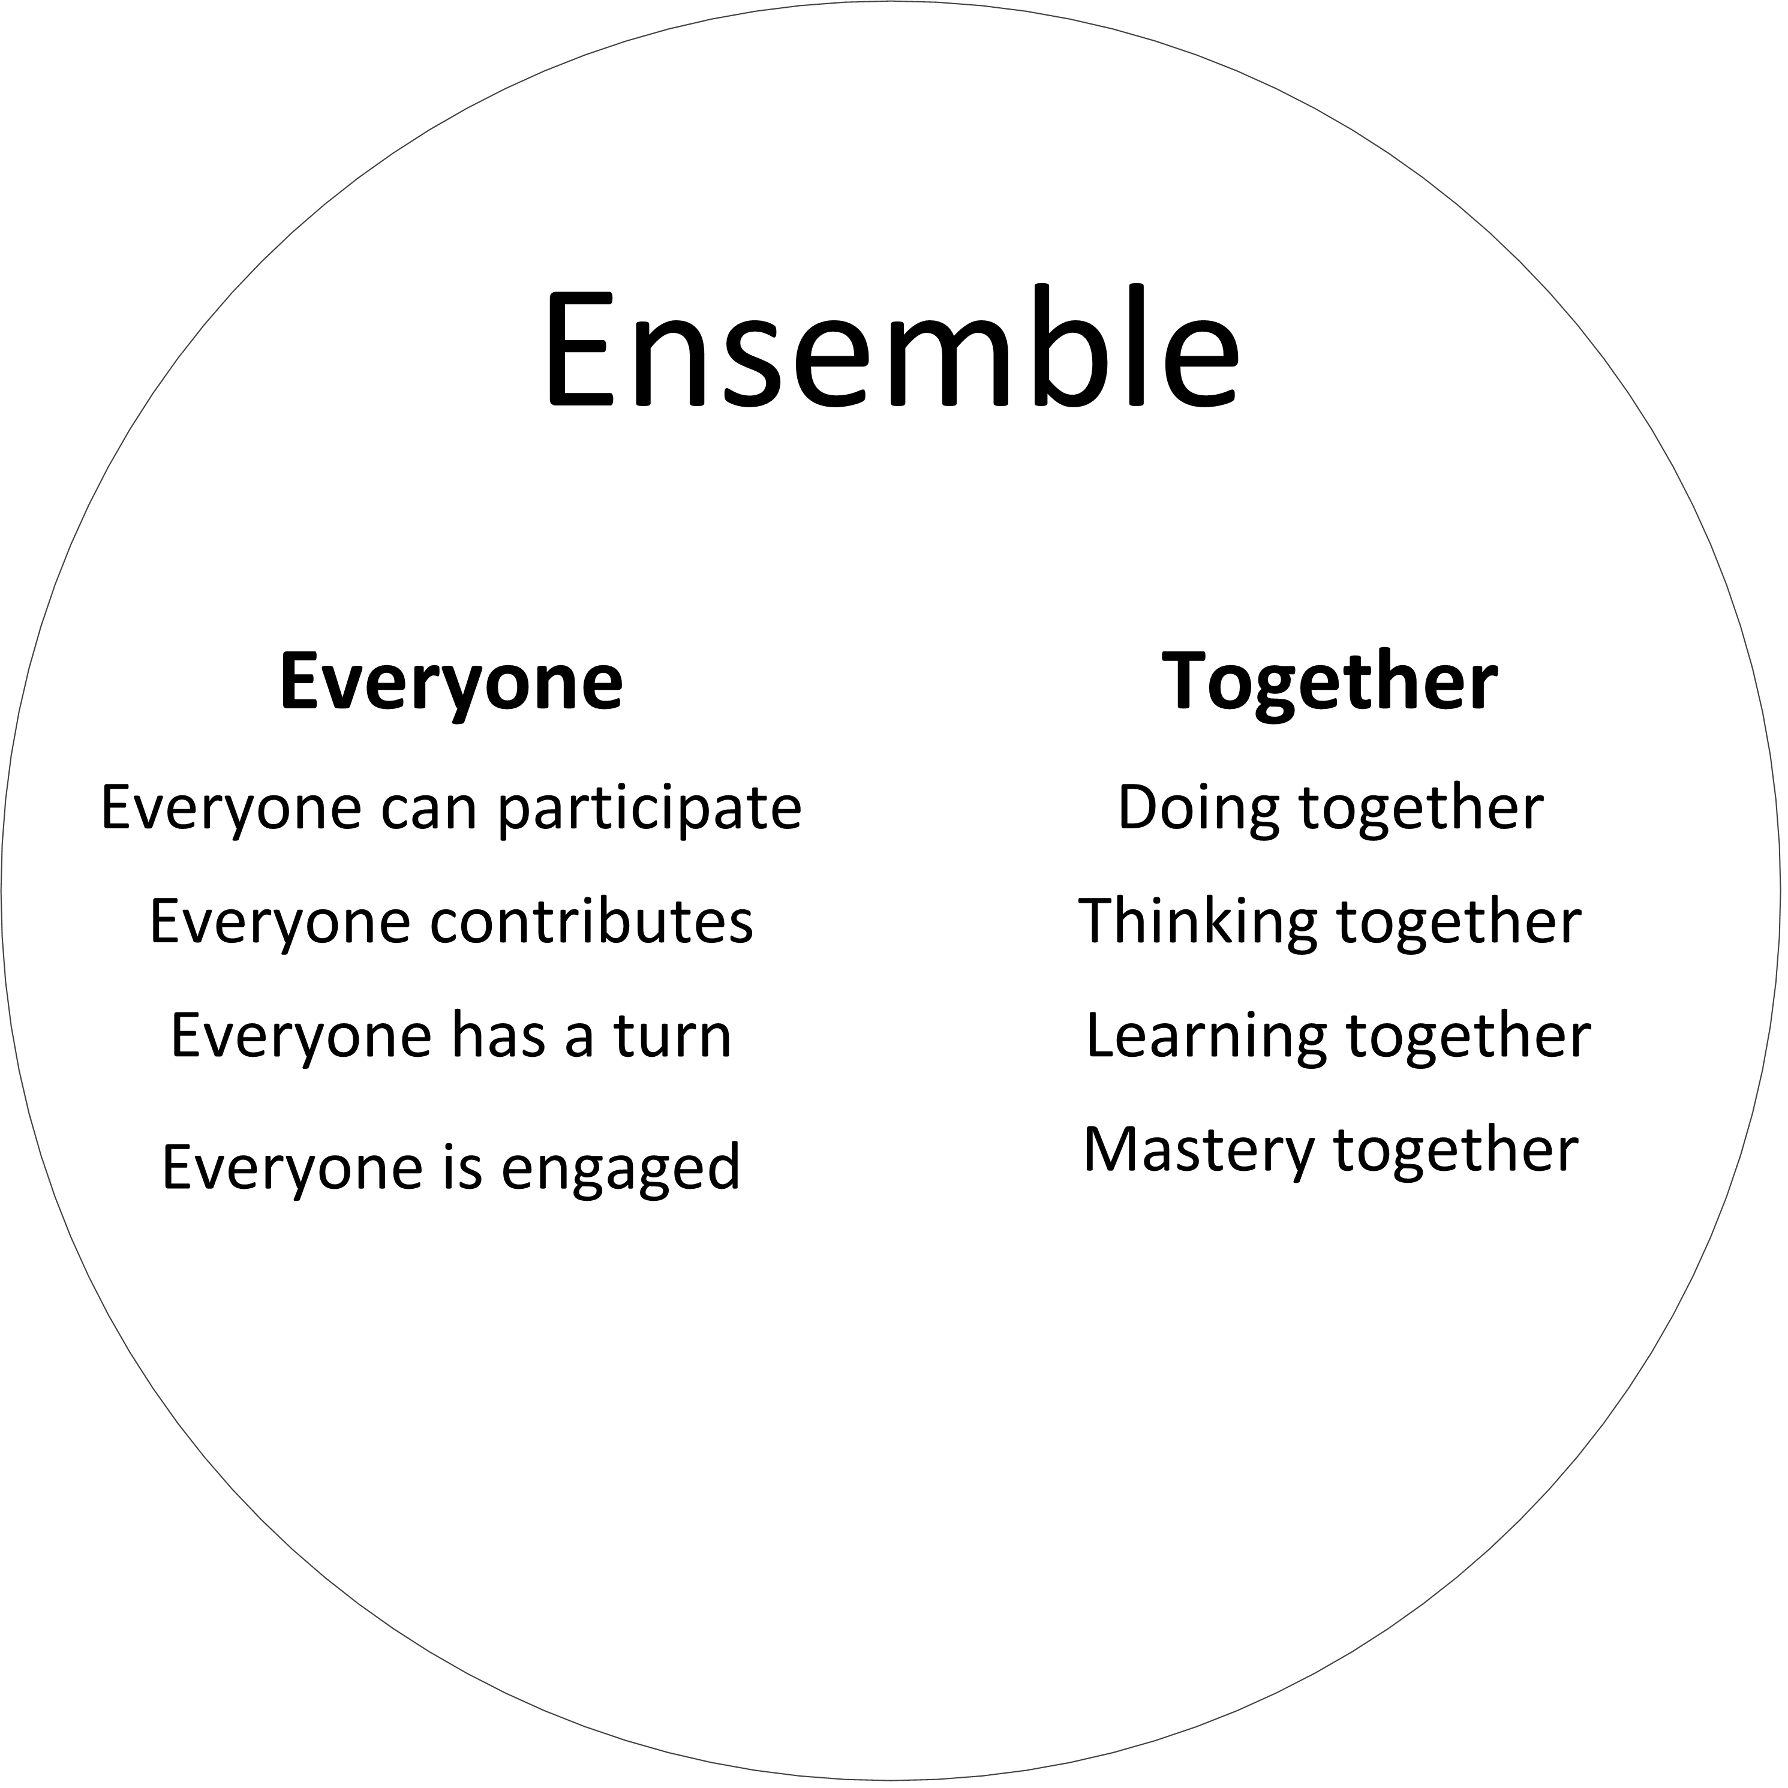
Teachers have found that acting as an ensemble is challenging but one of those involved in the London project encapsulated what can be gained.
It definitely changed the way my children sit, just in the classroom, so they’re all in mixed ability groupings now. And that idea that we’re all in it together and that there isn’t a good place and a bad place to be in the classroom, that we’re all here together and we’re all going to achieve together - rather than it being that one standout mathematician or those children that find it tricky - making it an ensemble, making it as a lesson where we’re all learning together, rather than individually.
These activities might not work the first time. And that’s OK. And that idea that we’ll make a mistake but we’ll make a mistake altogether and then we’ll correct that mistake altogether as well. So I think that’s what’s been great for them, that it’s not that one person who has made a mistake – we’ve all done, and that’s OK, we’ll go back to the beginning and we’ll do it again. I think that’s been really powerful. And it just changes the dynamics within the class and improves the dynamics within the class. We can all help together.

Embracing these ideas is not a quick fix. Ensemble takes time and a willingness not to succeed at first. But the benefits for the learning community can be significant.
Hilary Povey

Sample lesson adapted from EMP Multiples and factors module
Lesson 1: All together
In hall / gym / playground
Activity 1: Making the circle
We are going to work as an ensemble, which means working all together and thinking together.
Teaching point
The circle makes everyone equally important. And everyone can see everyone else.
If the activity goes wrong, it's everyone's responsibility.

Put a bean bag on floor.
Ask people to stand so that everyone is standing exactly the same distance from the bean bag.
The mathematics
A circle is defined as all the points which are exactly the same distance away from a given point. In this case, the bean bag provides the given "point" and the pupils are some of the "points" on the circle.
What is the shape we have made?
Why might it be a good shape for working together?
Check that you can see everyone, and enjoy that we are all working together.
Move the beanbag and reform the circle.
Have we made a circle the same size as before?

Now we are going to try something very hard, but very important. We are all going to try and see EVERYONE AT ONCE.
How can we do this?
Help the pupils to realise that by not looking at anyone special we can put everyone into our peripheral vision.
Let's all do it.
Now can you do it without moving your head at all? Yes! Why?
Our bodies and brains are very, very good at working and thinking together. We can all do it.

Activity 2: Moving together
Now we are going to think together.
We are going to all put our hands in the air at EXACTLY THE SAME TIME.
Someone watching should not be able to see anyone “leading".
Do this as many times as you like. The group will quickly get better at it. Remark on this.
What do you notice?
What do you feel?

You may find that you are “leading”. This usually happens to start with and is fine, but you will eventually want to remove yourself and watch them do this by themselves. You may also want to pick pupils to stand outside and watch to see if anyone is “leading”.
Can we all clap exactly together?
Repeat as necessary.
Reinforce that this is thinking together.

Activity 3: Walking the space
Now we are going to explore the whole space.
The group walk gently and slowly round the space in silence. Not in circles, and not with anyone else. They should imagine they are alone, and not look directly at anyone. They should try and keep the whole group in their peripheral vision, so that they “know” where everyone is. Then, by thinking and working together, find the exact second where everyone stops together. Again, you may find that they follow you, the teacher, so ideally work towards eventually them doing this with you observing. Stress the idea that if they really try hard to work together, the stopping is “magic”. Then move to them both stopping and starting together. You may then want to remove groups of pupils to watch, and see if they can tell if anyone is leading. What do you notice?
Teaching point
Whenever you are in a large space, this activity can be used at any time to improve the attention and awareness of the pupils as members of a learning community.
What do you feel?
What do you like?
What do you not like?

And now, from where we are, can we again all raise our hands exactly together?

Activity 4: Counting together
The mathematics
All hands are raised together first when the lowest common multiple (LCM) of the numbers is reached. After that, all hands are raised together on multiples of the LCM. Lesson two explores this mathematics in more detail.
All sit in the most beautiful circle.
Establish a simple beat.
All count together, clearly but quietly. To perhaps 12.
Count again. This time, all raise both hands on every multiple of 2. Count to 12.
Count again. This time, all raise hands on every multiple of 3. Count to 15.
Count to 24. This time, half the circle raise their hands on multiples of 2, the other half on multiples of 3.
Are there numbers at which we all raise our hands together? Which are they? Why?
You may need to repeat this exercise several times until all keep the rhythm all together. Now try swapping the two groups over.

Count to 20. This time all raise hands on multiples of 5.
Count again to 60. This time, a third of the group raise hands on multiples of 2, 3 and 5.
When do we all raise hands together?
Again, repeat the count until all keep the rhythm all together.
Again, swap groups and repeat.
Something to think about. If we counted in 3s, 4s and 5s, when would we first be all together? Why?
Being a mathematician
Looking for patterns.

Finish the lesson by standing up, and all raising hands together.
Did anyone learn anything new?
What does it feel like to think and work together?

